Active Partnerships
Equality & Diversity Policy 2017- 21
and Action Plan 2019-20

Approved by Active Partnerships Board (insert date)
Contents
Foreword by Active Partnerships Board Chair & Equality Champion
- Definitions
- Purpose of the Plan & Review
- Context
- Background to Active Partnerships
- Equality Statement
- Equality Aims & Objectives
- Roles & Responsibilities
- Equality Action Plan 2018-19
Appendix 1 – Diversity Profile of Active Partnerships national team & board and individual Active Partnerships

Foreword

The Equality and Diversity Policy confirms our commitment to this agenda and the Action Plan sets out the key areas we will undertake to develop this area of work both for the Active Partnerships board and staff teams, and the wider network of Active Partnerships.

Active Partnerships have been tasked by Sport England to reduce inactivity levels especially from under represented groups where significant imbalances exist. We need to understand the needs of these groups and involve them effectively in decision making if we are to have an impact on our collective goal.

We understand the benefits that a diverse board and staff team can bring especially around effective leadership and decision making. As the umbrella body for the network of Active Partnerships we also want to set high standards and act as an exemplar organization for the whole network.

The board has achieved tier 3 of the Code for Sports Governance and we will continue to commit to achieving gender parity and greater diversity generally on our board and staff teams.

Signed by Doug Patterson Active Partnerships Board Chair) & Sue Storey (Active Partnerships Board Equality Champion)

- Definitions

Equality – Equality is ensuring individuals or groups of individuals are not treated differently or less favourably , on the basis of their specific protected characteristic, including areas of race, gender, disability, religion or belief, sexual orientation and age. Equality is not always about treating everyone the same – it is about treating people in such a way that the outcome for each person can be the same.

Promoting equality should remove discrimination in all of the aforementioned areas. Bullying, harassment or victimization are also considered as equality and diversity issues.

Diversity – Diversity can be defined as having many people that are different from each other. Applied to organisations and decision-making groups, it can be understood as making them less homogeneous by taking into consideration factors like age, ethnicity, gender, disability, sexual orientation, educational background. Why is diversity important?

Diversity aims to recognise, respect and value peoples differences to contribute and realise their full potential by promoting an inclusive culture for all staff and students.

- Different backgrounds mean tackling the same idea in differing ways. A key risk to effective decision making is having individuals that all think the same way, due to sharing similar experiences and being from similar backgrounds. Group think has led to many poor decisions, with high profile adverse consequences.
- Our stakeholders, members, participants, staff and volunteers are diverse. It is important that all stakeholders feel it is possible to connect with Active Partnerships through seeing inspiring and visible role models.
- A diverse organisation can make your organisation more knowledgeable about and sensitive to a broader demographic and more adaptable to an ever changing environment.
- Diversity at board level can have a positive effect within the whole organisation, helping to create a more inclusive culture and in turn an improved reputation and stronger brand.

- Purpose of Plan & Review
The Diversity & Equality Policy and Action plan is an internal plan for the Active Partnerships national team.
The plan will contribute to our mission of the network “transforming lives by growing grassroots sport and championing active lifestyles” and ensuring that everyone has the opportunity to be involved in sport and physical activity. The Policy also outlines how Active Partnerships national team is committed to encouraging equality and diversity amongst its workforce, and eliminating unlawful discrimination.
The Plan will be reviewed and updated annually (normally to align with the September board meeting) and will be published on the Active Partnerships website (www.ActivePartnerships.org).
- Context

Code for Sports Governance
In April 2017, Sport England launched a new mandatory Code for Sport Governance (“the Code”) for organisations in receipt of government funding for sports projects from either UK Sport or Sport England. Requirements 2.1 to 2.3 of the Code set out provisions concerning diversity which all
organisations funded by Sport England will need to comply with.

2.1 Each organisation shall: (A) Adopt a target of, and take all appropriate actions to encourage, a minimum of 30% of each gender on its Board; and (B) Demonstrate a strong and public commitment to progressing towards achieving gender parity and greater diversity generally on its Board, including, but not limited to, Black, Asian, minority ethnic (BAME) diversity, and disability.

2.2 Each organisation shall identify proportionate and appropriate actions to be taken to support and/or maintain (as appropriate) the diversity targets set out in Requirement 2.1.

2.3 The Board shall ensure that the organisation prepares and publishes on its website information (approved by the Board) about its work to foster all aspects of diversity within its leadership and decision making, including an annual update on progress against the actions identified in Requirement 2.2.

Active Lives Survey
There are a number of factors that influence engagement in sport and physical activity as identified in Sport England’s Active Lives Adult Survey (March 2018).
Across all adults (16+) 6 in 10 (27.7m) are getting the health benefits from achieving 150+ minutes of activity a week. However, 25.7% do less than 30 minutes a week.
Socio-economic groups – Data shows that there are significant disparities between different socio-economic groups. People who are long term unemployed or have never worked (NS-SEC 8) are the most likely to be inactive (38%) and the least likely to be active (49%). People who are in managerial, administrative and professional occupations (NS-SEC 1-2) are the least likely to be inactive (17%) and the most likely to be active (71%).
Gender – There continues to be a gap in activity levels between men and women. Men (64% or 14.0m) are more likely to be active than women (60% or 13.7m). 24% of men and 27% of women are inactive.
Disability – Inactivity is more common for those with a disability (43%) than those without (21%). Furthermore, it increases sharply as the number of impairments an individual has increases – 51% of those with three or more impairments are inactive.
Age - Inactivity levels generally increase with age, but the sharpest increase comes between ages 75 and 84 (48%) and age 85+ (71%). Whilst activity levels have fallen slightly among the two age groups covering 16-34 year olds, with fewer achieving 150+ minutes a week, 75% of young people remain active. In contrast, activity levels have increased slightly among the 55-64 and 65-74 age groups.
The Principles of Good Governance for Sport and Recreation The Sport and Recreation Alliance ‘The Principles of Good Governance for Sport and Recreation’ promotes the recruitment of a balanced, inclusive and skilled board that reflects the diversity of the community it serves. Organisations can improve their decision-making and innovation by bringing together high-calibre individuals with varied experience, with the ability to think differently and the willingness to provide constructive criticism to board and executive colleagues.
The Principles of Good Governance for Sport and Recreation promotes the need for having 30% each gender on boards and encourages boards to aim for gender parity in the long run.

The Active Partnerships national team achieved the Foundation Equality standard in May 2013. All 43 Active Partnerships also achieved the standard, with 5 achieving the prelim standard.

Active Partnerships have secured a 3 ½ year contract with Sport England until 2021 to support the delivery of their strategy and in particular to support the reduction in the number of inactive people particularly from under-represented groups (see context section above). The Active Partnerships national team have also received funding from Sport England to March 2021 to support Active Partnerships with their improvement work including equality and diversity.

- Background to Active Partnerships

Active Partnerships is the national umbrella body (charity) which represents the nationwide network of individual Active Partnerships and supports them to collaborate, sustain, add value and deliver impact. There are 43 Active Partnerships who are all independent bodies with independent Boards. In total they employ approximately 730 staff. Individual Active Partnerships aim to increase participation in sport and physical activity by connecting national and regional policy with local need. They are made up of a collection of local and regional partners.

The Active Partnerships Vision is: “An active lifestyle is the social norm for everyone”

The Active Partnerships Mission: “To increase levels of engagement in sport and physical activity, reducing levels of inactivity, tackling stubborn inequalities and using the power of sport and physical activity to transform lives.

Our strategic outcomes are:
- Quality & Collaboration – continually innovating to improve standards and collaborating to unlock our collective expertise
- Stakeholder Value – providing attractive services to meet identified needs and consistently delivering above expectations
- Financial Sustainability – growing and diversifying funding sources to improve sustainability
- Performance & Impact – creating a value adding service offer, demonstrating impact on outcomes

All our work is underpinned by a collaborative, enterprising and high performance culture. Work is customer focused and equitable, providing everyone with the chance to be take part.

The Active Partnerships national team employs seven staff (5.2 FTEs) who are supported by officers from individual Active Partnerships who lead and help coordinate national work strand groups covering specific areas.

- Equality & Diversity Policy Statement
The Active Partnerships national team is committed to eliminating discrimination and encouraging diversity and inclusion within our workforce, in the partnerships we support and in the delivery of sporting activities and programmes. We oppose all forms of unlawful and unfair discrimination including direct and indirect discrimination, harassment, bullying and victimisation. Active Partnerships national team will abide by the requirements of the Equality Act 2010.
The purpose of this policy is to provide equality and fairness for those in our employment and all those we work with and ensure they are not unlawfully discriminated against because of age, disability, gender reassignment, marriage and civil partnership, pregnancy and maternity, race, religion or belief (including lack of belief), sex and sexual orientation (together the protected characteristics). Our aim is that our workforce will be truly representative of all sections of society and those we engage with and everyone feels respected and able to give their best.
All employees, whether part-time, full-time or temporary, will be treated fairly and with respect. Selection for employment, promotion, training or any other benefit will be on the basis of aptitude and ability. All employees will be helped and encouraged to develop their full potential and the talents and resources of the workforce will be fully utilised to maximise the efficiency of the organisation.
Our commitment is to:
- Create a working environment that promotes dignity and respect for all
- Ensure fair access to all to the opportunities we offer. The Active Partnerships national team recognises that it has a duty to make reasonable adjustments for disabled persons.
- To create an environment in which individual differences and the contributions of all our staff, sportsmen, sportswomen and volunteers are recognised and valued
- In the course of our work, eliminate discrimination and promote equality of opportunity between different groups in society
- Encourage Partner organisations, members and suppliers to demonstrate their commitment to the principles and practice of equality
- Develop programmes and action to help people realise their true potential by ensuring that training, development and progression opportunities are available to all
- Regularly review our all practices, policies and procedures to ensure fairness in our day to day work
- Help staff, those who participate in our programmes and volunteers to understand that breaches of our equality policy will be regarded as misconduct and could lead to disciplinary proceedings
- Monitor this policy and review it every year or when new legislation requires changes. Each time the policy is reviewed the Board will be consulted
- To take all complaints seriously and if necessary take appropriate measures against any stakeholder who unlawfully discriminates against, harasses, bullies or victimises any other person
This policy is agreed and endorsed by the Active Partnerships Board and is available on the Active Partnership website. We recognise that equality in the workplace and our day to day practice is not only good management but makes sound business sense.
The Chief Executive has overall responsibility for the implementation of this equality policy with the Business Support & Communications Manager having the day to day responsibility for the implementation of the policy and the board champion acting in an advisory role. Equality will be an agenda item at Board meetings at appropriate times.

- Equality and Diversity Aims & Objectives
Aims
- For our workforce to be representative of all sections of society and our customers, and for each employee to feel respected and able to give their best.
- Form effective partnerships with external stakeholders to ensure the work of the Active Partnerships national team, Board and the whole network enables everyone to have the opportunity to be involved in sport and physical activity.

Objectives

- Equality work is embedded across all our work streams.
- Develop partnerships with key equality organisations.
- Ensure communication is tailored to targeted audiences.
- Promote work / events linked to specific target groups.
- Ensure all individual Partnerships and national team retain the Equality Standard.
- Ensure there will be a minimum of 30% of each gender on the Active Partnerships national board and we will take all appropriate actions to maintain this.
- Demonstrate a strong and public commitment to progressing towards achieving gender parity and greater diversity generally on our Board, including, but not limited to, Black, Asian, minority ethnic (BAME) diversity and disability.
- Create a working environment free of bullying, harassment, victimisation and unlawful discrimination, promoting dignity and respect for all, and where individual differences and the contributions of all staff are recognised and valued.

- Roles & Responsibilities
Staff
The Chief Executive has overall responsibility for the implementation of this equality policy with the Business Support & Communications Manager having the day to day responsibility for the implementation of the policy supported by the Head of Operations.

Board

The board appoints an ‘equality and diversity champion’ who acts as an advisor to the board and staff and ensures sufficient attention is given to equality and diversity across relevant board and staff business. Equality and diversity will be an agenda item at Board meetings at appropriate times.

External equality advisory groups
Active Partnerships closely works with the Activity Alliance and Women in Sport. The Hub is used to share information and generate discussions linked to these areas. Active Partnerships have identified staff from individual partnerships to lead and link with National Equality organisations on behalf of network at a national level.
- Nicki Couzens –Women and Girls
- Activity Alliance & Disability Projects - Graeme Sinnott & Lee Mason
- Equality Action Plan 2019-20
Owner: BSCM (Business Support & Communications Manager); SE (Sport England); CEO (Chief Executive Officer); HO (Head of Operations); Inclusive Boards (IB); Head of Insight and Learning (HIL)

Active Partnerships Network Board
Task | Activity | Performance Measure | When | Lead / Support | Progress (updated Sept 2019)
Monitor make up of board | All board members to complete equality audit questionnaire, report to Active Partnerships national board. Align with SE survey. | Questionnaire completed | Oct 2018 | BSCM | Circulate in Sept and report to Nov board meeting.
Ensure a pro-active approach to equality and diversity as part of ongoing board recruitment | Ensure all recruitment processes give the national board best chance of achieving gender split and increasing diversity. | 30% gender split and good diversity across protected characteristics | ongoing | CEO | See current profile in Appendix 1. Lee - Insert how chair recruitment was following inclusive practice.  Board vacancies advertised on Sporting Equals Leader boards, Women on Boards as well as other websites. Only attracted male candidates.
Active Partnerships  Equality & Diversity Policy & Action Plan | Review plan and use board meeting to discuss and debate priority actions. Publish updated plan on website. | Review complete and plan updated | Nov 2018 | CEO | Board achieved Governance Code  Held meeting with Inclusive Boards to review Active Partnerships E&DP&AP  Inclusive Boards invited to Nov board meeting.
All board members undertake equality training | Identity appropriate online training programme | All board complete training | By Dec 2018 or within 3 months of start date | BSCM / HO | Currently researching best course. -

Active Partnership National Team
Task | Activity | Performance Measure | When | Lead / Support | Progress (updated Sept 2018)
Reapply for Equality Standard | Ask SE for guidelines, collect information and complete | Regain standard | ? | BSCM / SE | Contacted SE and waiting for information on re application process
Monitor make up of staff | All staff to complete equality audit questionnaire, report to Active Partnerships  National Board. Align with SE survey. | Questionnaire completed | Oct 2018 | BSCM | See appendix 1 for results 2018
All staff members undertake equality training | Identity appropriate online training programme | All staff complete training | By Dec 2018 or within 3 months of start date | BSCM / HO | All staff to undertake Educare online Equality and Diversity course. Reduced fee for course also has been negotiated for Active Partnerships national team staff.
Performance Management | As part of balanced scorecard update, consider appropriate equality measures | BSC reviewed and appropriate measures incorporated | By Dec 2018 | HIL | Work started and scheduled for debate at Nov board meeting

Active Partnerships
Task | Activity | Performance Measure | When | Lead / Support | Resource / progress
Work towards UK Sport and Sport England governance code Governance code | Training, webinars and support from Inclusive boards | Achieve code | 2019 | HO | All achieved code Jan 2019
National equality partners (Activity Alliance, Sporting Equals & Women in Sport)  National Partners involved in equality projects | Regular meetings to discuss opportunities for joint working | Action plan with each partner | Ongoing | AA = HIL  WS = BSCM  SE = BSCM | Regular dialogue with Activity Alliance Head of Engagement and Engagement Advisors working with Active Partnerships to share learning, successes and challenges.  Sit on a Sport England working group looking at approach of Active Partnerships to engaging people with disabilities and how standards are raised through sharing of best practice and the performance management improvement framework  Connection made with Frances Sport England, regular calls about TCG progress.
CSP Board Diversity Action Plans (DAPs) | Support Inclusive Boards to run DAP improvement project including introductory webinar. | All CSP meet IB to review DAPs | By Sept 2018 | HO | IB attending Nov board meeting to discuss findings  Feedback from Board Evaluation pilots  “Boards clearly recognise the value attached to achieving greater diversity of Board membership, as well as the imperative to comply with the Code for Sports Governance (requirements 2.1-2.3), but are grappling with how to achieve this.
Active Partnership staff Training | Work with Active Partnerships and partners to organise appropriate training for staff | Training included where appropriate.  Satisfaction levels per training course. | Ongoing | HO | Educare E&D course discount offered to all Active Partnerships staff – currently asking how many took up offer  Active Partnerships arranging local training to fit needs in LGBT+
Communications & Campaigns | Ensure project plans incorporate equality element  Work with partners to identify suitable campaigns to promote across the network  Consider areas of equality and diversity in all communications from Active Partnerships national team | Section included in project plans  Min of 2 campaigns per year identified  Website, enewsletter all contain suitable material | Ongoing  Ongoing  ongoing | BSCM  BSCM  BSCM | April 19-eNews disability story, disability images, teenage girls, females  June 19 eNews story – images of older females,.  Sept 19 eNews – image of older person, We Are Undefeatable campaign  Working with SE on TGC – parkrun and TGC looking to work together March 2020  Supporting #WeAreUndefeatable – looking to localise campaign. Connections made with Stroke Association  Web imagery reflect diverse groups.  Promoting relevant work of Active Partnerships  Safe Space for Young People  Gold at the end of a rainbow

Appendix One Equality Profile of Active Partnerships Board / Staff and Active Partnership Leadership Team

Figure 1: Gender Profile of Active Partnership Board, CEOs, Chairs and Staff teams
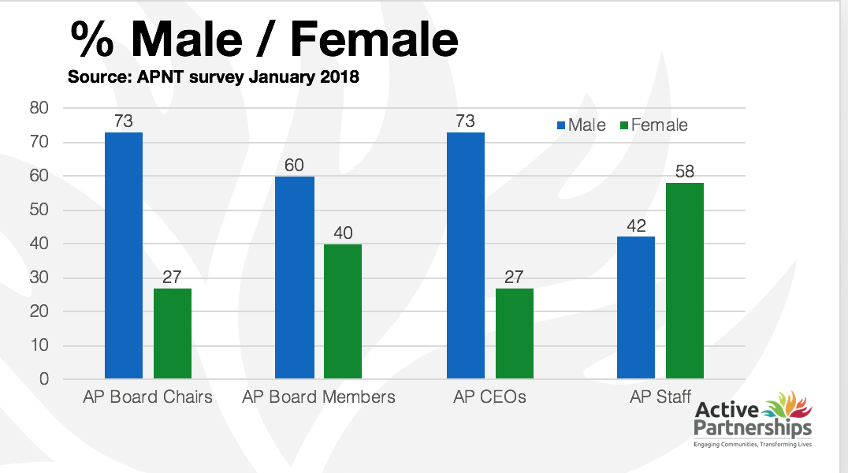

Figure 2: Gender profile of Active Partnership National Board and Active Partnerships Leadership Team compared with general population. (2019)

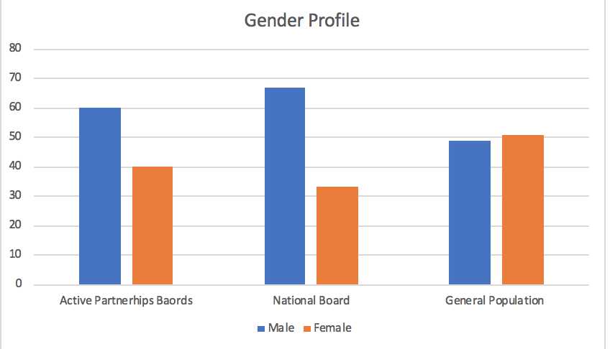

Figure 3: Race profile of Active Partnership National Board and Active Partnerships Board Active Partnership Network Board and Active Partnerships (Diversity in Sports Governance Survey 2018-19)
Source: Inclusive Boards
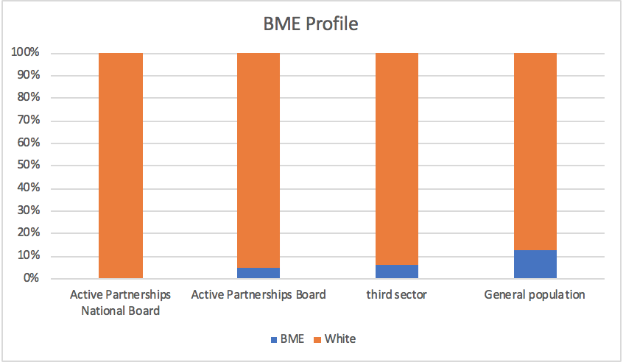

Disability
•5% of Active Partnership board members declared or consider themselves to have a disability, compared to 22% in the wider UK population
•3% of Active Partnership board members identified as being openly LGBT+, slightly above the 2% average for the UK population

