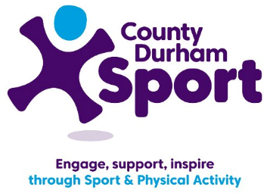
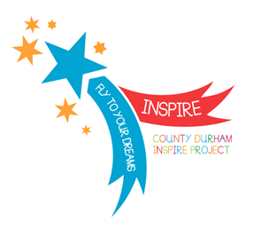
County Durham Sport –
Overview

Nationally one in ten children aged 5-16 has a mental health problem. Empirical evidence suggests a strong correlation between mental ill-health and deprivation, low educational attainment and unemployment with County Durham being amongst the worst in England against each indicator.

Through the use of customer insight and consultation, it was identified that primary schools across County Durham would welcome a programme which would promote mental well-being in their pupils by building resilience, inspiring confidence and helping to develop self-worth, through the power of sport.
The Inspire Project was born in response to this demand and work began in September 2015, with Olympian Chris Cook, to develop, co-ordinate and deliver a pilot of the project in five primary schools across the county. The project was modelled on a piece of work Chris has been doing for Kent County Council over a number of years.
Issues such as low levels of resilience and self-worth are addressed by the Inspire Project through the delivery of effective and engaging workshops where children are provided with practical activities which are challenging, fun and designed to support ‘self-awareness’ as well as promoting mental well-being.

The delivery mechanism ensures that schools receive a programme which meets their specific needs, and can be offered across the whole school or to specific year groups or target groups.
Following a whole school assembly with the athlete mentor, schools receive a series of visits throughout the year and continue to build the ethos between visits. Schools are given both ownership and flexibility of the project as all resources can be tailored to the specific needs of the pupils and teaching staff are freely able to decide which topics would be most beneficial to deliver to their pupils.
The Inspire Project is comprised of four unit modules (Dreams, Goals & Ambitions, Stepping out of the ‘Comfortable Zone’, Mindfulness, Your Body & Your Emotions and Role Models) which are designed to support young people’s emotional well-being and the development of a rounded young person, using sport, physical activity and athlete role models as the tool.

Paralympian Tim Prendergast is now on board as another athlete mentor for the project and County Durham Sport are offering the programme at a subsidised rate to all primary schools in the county with the first pilot schools offering additional knowledge, support and resources to the wider primary school network, thus contributing to the sustainability of the project.

Aims & Objectives

The aim of the County Durham Inspire Project is to deliver an innovative project by brokering relationships with a number of primary schools across the county. The development of these relationships will result in a strong primary school network who work together to offer the best opportunities to all their pupils and enable the Primary School Sport Premium to be used effectively to support the development of a rounded young person through the power of sport and physical activity.

The additional aims of the project are to:
- Build resilience in children by providing them with the tools and knowledge to develop effective coping strategies
- Help children to focus their attention in the correct way in order to maximise achievement
- Equip primary school children with the appropriate support and guidance to allow them to make informed and effective decisions about their futures
- Encourage children to pursue their dreams and goals, even in the face of adversity.
Inspire Project
Feedback  Andrea Jones,  Prince Bishops Community Primary School –  “We use it [the Inspire Project content] a lot, not just in PE but in every single curriculum aspect so it’s worked absolutely brilliantly.”  Beverley Jones,  Cotsford Junior School Head Teacher –  “They [the children] were all really focussed on Chris and the story he had to tell, it was fabulous.”  Key Stage 2 pupils, Peases West Primary School:  “Chris inspired me to follow my dream of being a footballer as he followed his and became a swimmer.”  “Chris was very inspiring and told us all to ‘dream big start small’ which means have small goals which lead to big things.”  Key Stage 2 pupils, Cotsford Junior School:  “I just let go and I wanted to go for my dreams.”  “It [the Inspire Project work] has helped me to push further rather than sticking in one spot.”  Key Stage 2 pupils, Prince Bishops Community Primary School:  “We have to do SATS in Year 6 and I had been a bit worried, but because of learning about different zones, I have got a lot more confident with them.”  “I have done more sports now and have even set my new year’s resolution to do more sports outside of school.”  “We learned about different ways to think about yourself like being happy and sad sometimes and how to deal with these feelings better.”  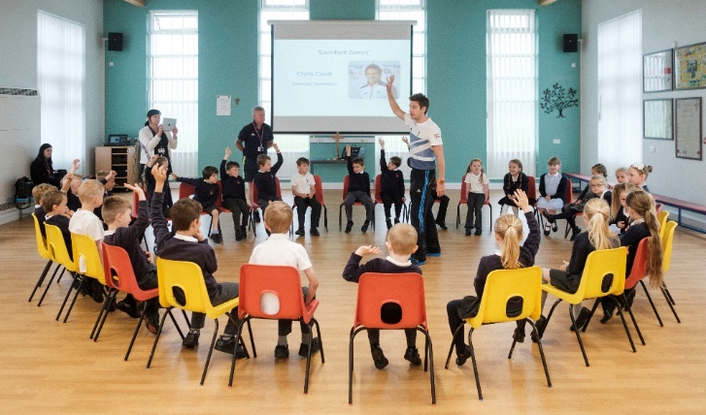  Lynne Wightman, Development Manager, County Durham Sport lynne.wightman@countydurhamsport.com | Success & Impact  The Inspire Project has been welcomed enthusiastically by all Head Teachers involved. Work with a Children’s Rights organisation and the Education Development Service has measured the impact of the project on the pupils’ wider learning, through student voice activities and assessment visits to schools. The feedback so far has been very positive, providing strong evidence that the aims of project have been achieved through primary pupils displaying higher levels of resilience and improved mental well-being in their day-to-day activities.  The major successes of the project are:  - Several Year 6 children spoke about the reassurance the Inspire Project had given them during SATs week  - Primary pupils explained how the project helped them to develop a greater understanding of themselves as they felt as though they were able to push themselves further with less pressure  - Teaching staff commented that that the project promoted positive thinking and self-belief among pupils  - There has been substantial evidence of increased engagement in school PE and sport following the programme  Both teaching staff and pupils have also commented that the positive impact the project has on the young people’s health and wellbeing will also support their transition into secondary school, and enable schools to engage more pupils in extra-curricular activities.  Alongside the Inspire Project work, a number of schools are also working closely with County Durham Sport to deliver and measure the impact of Young Sports Leader programmes with upper Key Stage 2 pupils, over the course of a two year pilot project.  The Young Sports Leader programme compliments many components of the Inspire Project as pupils are given the opportunity to develop many important life skills, work towards and achieve goals as well as recognising and identifying themselves as role models.  The impact of these programmes on the Young Sports Leaders themselves, the number of extra-curricular sports opportunities offered by the school and the number of pupils participating in extra-curricular sport has been measured through collecting both qualitative and quantitative data.  So far, 100% of teaching staff have reported that the programme has increased pupil participation in sport and physical activity as well as over 65% of pupils reporting that the programme has helped to develop their organisation, time management and communication skills.  Melissa Morton, Peases West Primary School:  “We would definitely run the Young Leader programme again as it gives the pupils a sense of responsibility and has helped to increase school participation in PE.”

