County Durham Sport Inspire Project for Primary Schools
Overview
County Durham Sport have established a strong working relationship with Olympian Chris Cook with whom we have been working to develop and deliver the Inspire Project in six pilot primary schools across the county. The project was modelled on a piece of work Chris has been doing for Kent County Council over a number of years.
The Inspire Project was launched in September 2015 offering nominated primary schools the opportunity to receive some bespoke work from Chris. This involves selecting a workshop from the available options and working with Chris to deliver then build on the resource. The delivery mechanism ensures that the school receives a programme which meets their specific needs, and can be offered across the whole school or to specific year groups or target groups.
In future years, County Durham Sport will continue to offer the programme at a subsidised rate to other primary schools with the first project pilots offering additional knowledge, support and resources to the wider primary school network.
Aims & Objectives

The aim of the Inspire Project is to develop a network of primary schools who work together to offer the best opportunities to all their pupils and enable the Primary School Sport Premium to support the development of a rounded young person through the power of sport and physical activity.

The additional aims of the project are to:

- Build resilience in children by providing them with the tools and knowledge to develop effective coping strategies
- Help children to focus their attention in the correct way in order to maximise achievement
- Equip primary school children with the appropriate support and guidance to allow them to make informed and effective decisions about their futures
- Encourage children to pursue their dreams and goals, even in the face of adversity.

Project Delivery
The programme is structured as follows:
- Chris delivers an initial session delivered to the staff at a primary school to introduce the programme and establish the outcomes. This is often in a whole team meeting, so that all school staff understand the the activity and associated outcomes.
- An introduction and welcome to the school then the pupils participating in an assembly with Chris (with a whole school focus)
- A menu of workshops for the schools to choose from (all workshops can be led by Chris with a focus on either a specific year group or target group for 40-60 minutes)

A resource pack is provided to schools before the initial visit so teachers can access activities and resources and do some prep work.
Following the initial session and the school assembly, the school receives three visits; one per term with the final visit being a fun celebration for the school. For example, Chris may go swimming with pupils or visit the school again and celebrate the children’s work and achievements over the year.
Prgramme Outline
The Inspire Project is comprised of four unit modules: Dreams, Goals & Ambitions, Stepping out of the ‘Comfortable Zone’, Mindfulness, Your Body & Your Emotions and Role Models. Schools are given both ownership and flexibility of the project and any of the resources can be tailored to the specific needs of the pupils. Teaching staff are freely able to decide which topics would be most beneficial for their pupils. The Dreams, Goals & Ambitions module highlights the importance of young people taking the time to work out their innermost interests, taking the most appropriate steps to act in alignment with these interests then following them with passion and enthusiasm. The activities related to Stepping out of the ‘Comfortable Zone’ help children create an idea of where their comfort zones are, how to ‘step out’ and push their boundaries and learn what the benefits of stepping outside of their comfort zones could be. Mindfulness, Your Body & Your Emotions encourages children to relax and take the time to explore who they are, what their thoughts and feelings are telling them and helps them feel more connected, with a sense of balance in life. They explore techniques and exercises to promote a deeper connection with themselves, whilst understanding the benefits on their mind, body and emotions. The final module, Role Models, aims to develop a sense of awareness of who role models could potentially be as well helping children to understand what a good role model could/should look like, what qualities a role model may need to possess, what qualities our young people share with their role models and, most importantly, explores the ways in which the young people could be viewed as role models to their peers.
Success & Impact
The majority of pilot primary schools for the Inspire Project are situated in deprived areas of County Durham where employment rates are low and many children often struggle to achieve and have been found to have low levels of resilience and self-worth. As the aim of this project is to support the development of a rounded young person through the power of sport and physical activity, the four unit modules are structured and delivered in a way which can help to improve children’s resilience, not only in school, but in their home lives as well.
The project is still in its early stages of delivery, schools have so far only received one visit from Chris, however the schools involved state that the project is having a positive impact on their pupils. Teaching staff are reporting that their pupils are eager and enthusiastic to build on the work with Chris and they are showing greater resilience when tackling challenging situations by striving to improve their performance and not giving up. The schools use the resources throughout the school week, related information is on noticeboards and in classrooms, and pupils are planning towards the next visit.

The Inspire Project work is being utilised across the whole curriculum and not just restricted to PE. The topics covered in all four unit modules can be adapted to fit in with any learning objectives or outcomes with staff incorporating the messages delivered by Chris into all curriculum subjects.

“We use it a lot in every lesson, not just PE, in every single curriculum aspect so it’s worked absolutely brilliantly.” – Andrea Jones, Prince Bishops Community Primary School

Work is under way with Investing in Children and the Education Development Service to measure the impact of the project on the pupils wider learning, through student voice activities and assessment visits to schools. CDS, Chris and participating Head Teachers will be delivering a workshop on the project at the County Durham PE Conference at the end of January, to offer opportunities for more schools to take part in the next academic year.

The programme is welcomed enthusiastically by all the Head teachers involved, with some displaying genuine emotion when Chris has been delivering the assembly to their pupils. It is easy to see the impact the programme is having through engaging with the staff and pupils, who are enthused by the work and are planning for their next session with Chris, as well as referring to much of the content in their daily lessons.

Through developing the whole child, and enabling teachers to deliver and build on elements of the programme, we believe the outcomes of the project will be sustainable in the long term. In future years older pupils will be confident and able to support younger pupils, and schools will retain the key messages from the programme throughout their curriculum. The programme has been developed so that the schools can own it, once initial sessions with Chris have taken place, and therefore it can become embedded in school life. The aim now is to engage with more sporting role models who will support Chris and CDS in delivering the programme, enabling more schools to benefit from the resource.

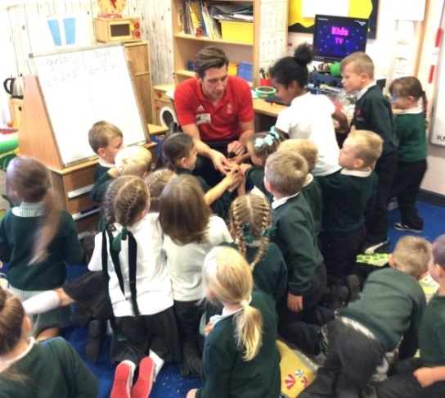
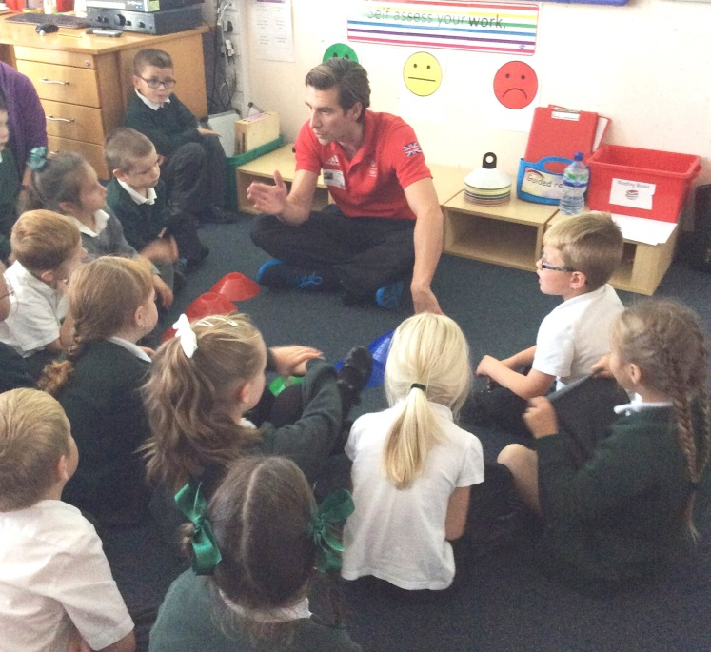

Feedback from schools and their pupils
“All school staff are really on board with the project, every class now has a display showing the ‘Comfort Zone’ target with both staff and children referring to it on a daily basis.”
– Andrea Jones, Prince Bishops Community Primary School
“Chris inspired me to follow my dream of being a footballer as he followed his and became a swimmer.” Pupil
“Chris was very inspiring and told us all to ‘dream big start small’ which means have small goals which lead to big things.”– Key Stage 2 children, Peases West Primary School
“They [the children] were all really focussed on Chris and the story he had to tell, it was fabulous.”
– Beverley Jones, Headteacher - Cotsford Junior School
“I just let go and I wanted to go for my dreams.” Pupil
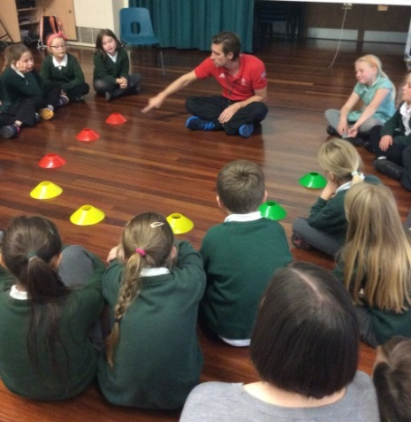
“It [the work with Chris] has helped me to push further rather than sticking in one spot.”- Key Stage 2 children, Cotsford Junior School
