CSPN Impact Award Entry: Kent School Games Volunteer Training Programme 2016

Sporting Future Strategy social outcome delivered: Individual Development

Supporting DVD: https://www.youtube.com/watch?v=7XHxX1PviII

What we did:
Having delivered a number of very successful level 3 volunteering training days, Kent were keen to develop the offer and access a wider network of young people. Historically the content and delivery of the training had been led by adults/ professionals (CSP staff, SGOs etc). The challenge we set ourselves was to enable university students to deliver and design the content of this training on our behalf!

Working in partnership with Canterbury Christ Church University, students in year 3 studying BA (Hons) Physical Education and Physical Activity were targeted. As part of their course they were required to complete a module titled Physical Education, Physical Activity and School Sport.

The module aims to enable students to develop and apply advanced subject knowledge, skills, application and understanding in the range of practical activities in relation to the Early years Foundation Stage (EYFS) and the National Curriculum for Physical Education. Students will develop a conceptual understanding in a range physical activity and sports. Students will have opportunities to analyse and reflect on personal and professional requirements in physical activity and sport in the work place.

In one of their sessions the students were introduced to the concept of the School Games from a national to local perspective, outlining the demands and expectations placed upon the Local Organising Committee in regards to student workforce. The students were given an overview of what is expected from the Young Leader workforce at the KSG Finals and what training has been traditionally delivered to the young helpers. Armed with the understanding of the expected outcomes form the training day, the students explored the different pedagogical approaches to deliver the 2016 training in the most effective (and engaging) way to the Young Leaders.

The students were then divided into small groups, and given specific responsibility for planning, organising and co-ordinating different aspects of the Young Leader training event. Working alongside the KSG staff they created specific training sessions.

The students delivered a ‘rehearsal’ session with a group of Young Leaders from Thanet schools and used the session not only to help them prepare for the training day, but also to explore their observation and feedback skills – reviewing each other’s’ delivery skills and providing key feedback for future delivery.

Working from the University of Kent location the students delivered their training to 103 Young Leaders from across Kent, on a carousel system in June 2016.

As part of the summative assessment for the module, students have to complete a 1600 word assignment as either a case study or essay. The students that chose to complete the case study of a learner’s experience in physical education, physical activity and school sport were able to use the volunteer leader training day to engage with their ‘case study’ students and begin to observe their behaviours and performance throughout the day.

Project impact/ outcomes:
- Accessing and engaging a new partner to the School Games (Canterbury Christ Church University)
- The university students delivered the training sessions in an innovative and more interactive way than seen previously.
- Students were evidencing and utilising a real life project as part of their university studies
- A sustainable module has been created
- The individual development of the students from the point at which the concept of the games was articulated through to training delivery was quite significant and proved to be a journey of self-discovery.
- 103 young leaders were given the confidence, skills and knowledge to support the delivery of a successful games which included some high profile guests:

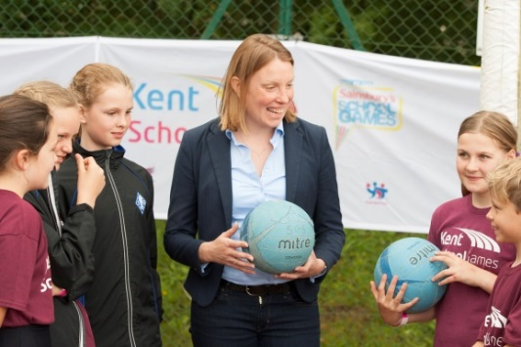

For further information contact:
Natalie Harris
E. Natalie.harris@kent.gov.uk
M. 07920585492
www.kentschoolgames.com
Twitter: @KentSchoolGames
Facebook: Kent-School-Games
Instagram: KentSchoolGames

