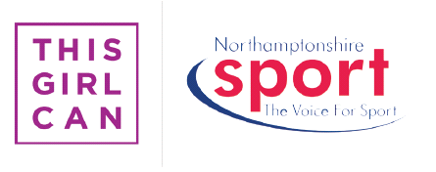


#NorthantsGirlsCan
The #NorthantsGirlsCan fund was set up and launched in October of 2015. The fund was initiated off the back of the huge campaign from Sport England, This Girl Can, which aimed to increase the ever depleting number of Women that participate in Sport.
The #NorthantsGirlCan Fund allows groups, organisations and clubs to create physical activity opportunities to engage women of Northamptonshire. The start-up grants are a generous £500 which can be used to cover coaching, equipment and facility costs to support a project between 6 to 12 weeks long. Northamptonshire Sport works at the forefront of the projects that are set up of the back of the fund to ensure it reaches the intended audience.
Since 2015 the #NorthantsGirlsCan fund has funded 15 projects that will specifically target females over the age of 25 throughout the county. The projects have brought new experiences of Martial Arts, Zumba, Netfit, Swimming, Badminton, Tennis, Basketball, Volleyball & Golf to audiences of Women who previously didn’t have access to such sessions.
Over 250 women have engaged in physical activity and sport across 12 completed projects to date, with over 50 more ladies exercising through ongoing projects that are being funded by #NorthantsGirlsCan. The sessions were subsidised by the funding received in order to entice female engagement and it was fantastic to see this was met with an average of over 20 ladies attending each activity. A requirement of the funding was the ability to keep the project sustained after the initial course of funded sessions and at Northamptonshire Sport we were delighted to see 10 of our projects create a sustainable environment in which the ladies can continue the physical activity.
The project criteria consisted of:
• Activity must target women of 25 and over.
• Activity must run for a minimum of 6 weeks and can continue for up to 12 weeks.
• The activity must lead to a local exit route or sustainable session i.e. a local dance club or continuation of the session through participant funding.
• Activity must be a new initiative or be over and above the current provision.
• A charge should be made to the participants, either as a pay as you go basis or as an upfront cost.
• Sessions should be coached or led by someone with an appropriate qualification.
• Funding can be used for coaching costs, facility hire, equipment and promotion of sessions.
• Partnership funding is not a necessity but is encouraged.
Using two of the projects approved by the funding we will look at the impact the funding has had.
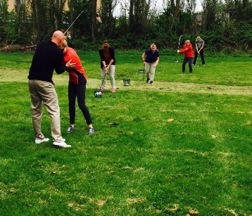
Theresa East from Northamptonshire Golf, who co-ordinated the project ‘This Girl Can Golf @ Lunchtime’ along with Northamptonshire Sport was thrilled on reflection of the project. She was excited that local businesses in the area were keen to engage their employees to try something new. Employees at Barclaycard and John Dryden House were regular attenders and it was pleasing to see, especially after the work that Northamptonshire Golf had gone to in promoting the sessions to the surrounding businesses. Her engagement with the local businesses was without doubt a real strength of the project, meeting with local contacts and exerting her fantastic positive influence and enthusiasm, which was so essential in engaging with local women and encouraging them to come and take part.
At Waendel Leisure Centre, we worked in partnership to put together a new female only Beginners Swimming
Lesson project. Rachel used her considerable experience throughout the lesson to guide and aid the ladies throughout the lesson, being a fabulous support to any worries or questions the ladies had. After the sessions finished, tea and coffee were supplied allowing the participants and a member of staff to talk through their experiences, achievements and goals for going forward.
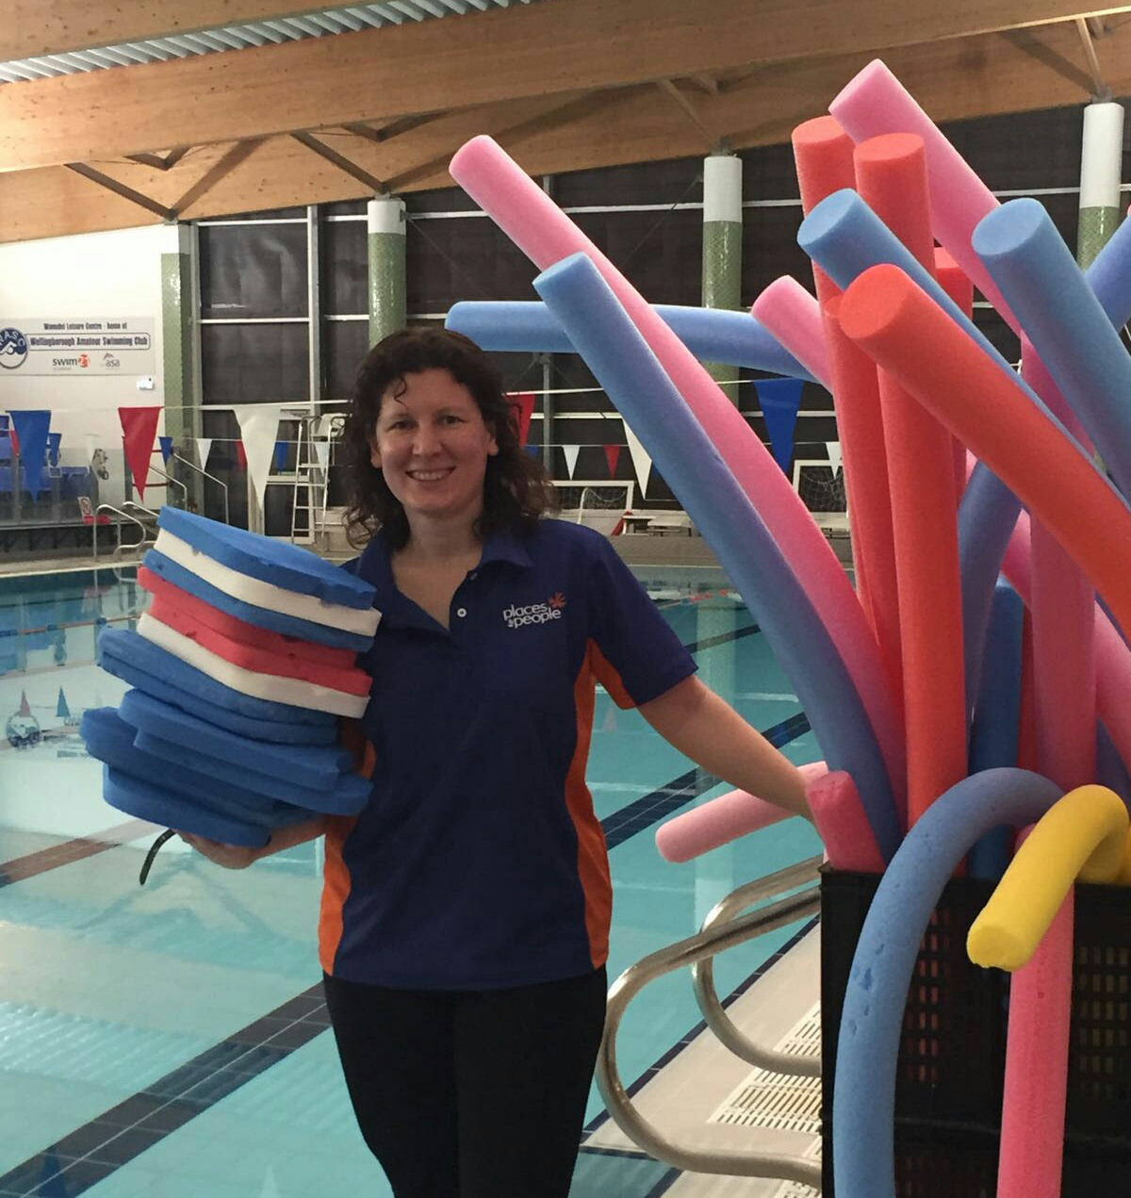
The sessions had a fantastic start with 17 ladies turning up on the first week across two half an hour sessions. With ages ranging from 34 to 73, a total of 20 ladies attended the free sessions, 85% of which took part in at least 5 of the 8 sessions available, with 25% of them completing all 8.
The project has been a huge success and Waendel Leisure Centre has already had 13 of the 20 women sign up for the further lessons at the agreed discounted rate, with a waiting list already being put in place for the in demand ladies only sessions. Donna, Rachel and the project as a whole were all mentioned favourably in the feedback from the participants and as a whole the project proved to very successful.
Off the back of this project, participant Laura Martin was awarded the Get Active award at our Northamptonshire Sport Awards 2016. Diagnosed with Emphysema and Polymyalgia Rheumatica, Laura uses exercise to keep the diseases in check. As a non-swimmer, Laura signed up to the 10 week programme of lessons for women only and can now swim up to 52 lengths. Laura has lost weight and has made many new friends showing an example of the fantastic impact the #NorthantsGirlsCan fund has had females in the county.
Overall the #NorthantsGirlsCan projects funded by us at Northamptonshire Sport have provided new and inclusive activities for females to engage or reengage with or physical activity. Using the Sport England research to ensure that in partnership with This Girl Can barriers of females in our county are considered, with best efforts given to ensure these are minimised. The start-up fund provided has allowed ongoing participation in many of the sports and activities and will continue to do so across the county.



