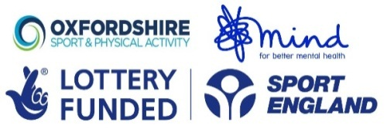
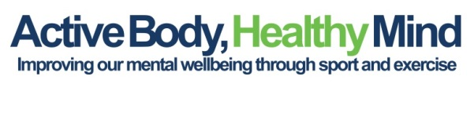

CSP Network Good to Great Impact Awards 2017
Active Body, Healthy Mind (Oxfordshire Sport and Physical Activity)

Active Body Healthy Mind (ABHM) recognises the very specific barriers faced by people with mental ill health to improve their physical health through participation in sport and physical activity. ABHM is delivered by a consortium of mental health organisations, providing carefully tailored activities in settings and times that are appropriate to the participants. The programme has helped to reduce fear and build confidence of participants, resulting in an improved mental attitude and a lasting participation in sport and physical activity. Key to the sustainability of the project has been the up-skilling of both the participants, and the mental health organisations. Fifteen participants have progressed to become activity leaders, whilst two mental health organisations have committed to continue the project, funding a full time programme manager from their own resources.

Following an initial project scoping exercise with partners, Oxfordshire Sport and Physical Activity (OXSPA) sent out an expression of interest invitation to over 30 organisations, with 2155 eventually recruited to the programme. The project piloted a new approach across the partnership, with a person-centred approach that focussed on entry and referral, and ensured the most appropriate, and supportive environment in which to deliver the carefully tailored activities. It was important to ensure that the intervention fitted with both the participants and the mental health organizations’ needs.

Before the inception of ABHM, the relationship between, and within, the mental health sector and sport and physical activity was limited and fragmented. The OxSPA led project team has ensured that mental health organisations, which had previously not worked together, recognize the benefits of working together to achieve common goals, sharing resources and information. The programme has been delivered across the full spectrum of MIH with partners that have high levels of expertise in their respective fields.

Through our work trialling different delivery models our conclusion was that small (6-8 people) supported groups sessions run in familiar areas were the most beneficial for participants and efficient to run as an intervention. ABHM has exceeded target by 47.7% (engaged 2155 participants over 3.5 years (Target 1459))

Consultation with the mental health specialists has been extensive, both pre-delivery and mid project. An ABHM consultation workshop held in January 2017 helped to identify what works and what does not. In the delivery of the project it became clear that we could not use a “one size fits all” methodology.

Training has been provided to both the mental health, and the sport and physical activity, sectors.
- Mental health first aid training for sport and leisure staff
- Mental health awareness training for sport and leisure staff
- Sports qualification training for participants
- Sports activity training in 30 different sports

As participant’s confidence has increased, over 50 ABHM project participants have been supported back into paid work. Although this was not one of the aims of the project, the partnership working and expertise of partners within the project has enabled this to happen and we are very proud of this additional success.

ABHM takes place in over 50 different venues across Oxfordshire, including 21 Leisure Centres, 11 Mental Health Partner Venues and 18 other sporting/community venues. This helps people to access public venues, and the leisure and sports sector gain practical experience in supporting and welcoming people with MIH. Through this project 8 mental health staff have gained sports coaching qualification, improving the ability of mental health partners to deliver sessions as well as increasing the number of sports coaches with extensive mental health knowledge.

Before the creation of ABHM in Oxfordshire there was limited joined up working within the mental health sector. As a direct result of the project two key partners, Oxfordshire Mind and Aspire, have adopted the “Active Body Healthy Mind” brand for all their sport and wellbeing activities. More importantly, they have both committed to maintaining a full time officer role to coordinate the activities and service that has been created by this project. As a result of partners sustaining this work without current project funding, the lessons learned from this project will continue to benefit people with MIH in Oxfordshire, and the project will continue to grow, and innovate.

