Programme Description
Fit Villages is a project that is delivered in Suffolk's smallest villages, bringing physical activity to village communities that do not have any other provision for people to be active or take part in regular exercise. This much loved local project was highlighted as a case study example of good practice in sport England’s latest Strategy ‘Towards An Active Nation’. Starting out as a means of overcoming rural transport issues and barriers to activity; it has evolved and developed into the highly successful and much sought after flagship rural project it is today, impacting individuals and communities far beyond their physical wellbeing. The project is supported by Suffolk County Council and Sport England as part of Suffolk’s collective aspiration to be the Most Active County in England.

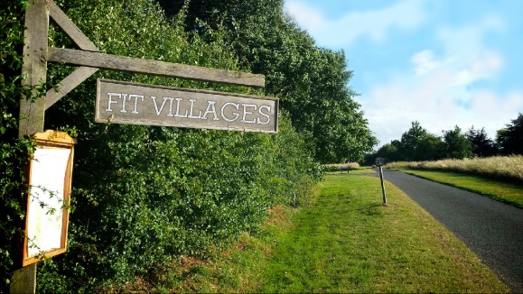
Customer Insight and Engagement
The project’s success is built upon a collaborative approach with local communities. The Fit Villages Co-ordinator contacts Parish Councils, Village Halls or other community groups in small villages, to offer them the opportunity to access Fit Villages. A local volunteer “Activator” is recruited to assist with the project in their village & we work with that Activator to help run a community consultation to establish popular activities and timings. The projects are advertised through existing community groups, in local Newsletters, poster and flyer distribution, through social media and most importantly word of mouth.
The project responds directly to the evidence base, research and consultation that form the context for sport and physical activity in Suffolk. In particular:
- The needs of low participation groups in rural parts of the county, particularly females;
- Existing barriers to participation and access to other services in rural areas;
- The focus of using Suffolk’s rural assets as settings for physical activity and sport;
40% of Suffolk’s population lives in rural areas where significant gaps in provision exist, not only in terms of opportunities for physical activity but also in terms of access to wider services.
Key Objectives, Evaluation and Outcomes
Fit Villages works in Suffolk’s rural villages targeting inactive adults in hard to reach communities. The project works with local higher education institutions; University of Suffolk and University of East Anglia to provide robust evaluation and recent results have shown that 90% of the participants are female and over 75% are aged 50+.
Other key outcomes include;
• Increased levels of vigorous and moderate activity and walking
• Reduced amount of time sitting
• Increased connection of participants to their community
• Reduced social isolation
Softer outcomes are measured through focus groups and case studies; these really focus on individuals stories and the impact Fit Villages has on their life. The most recent case study was filmed in Freckenham, a very small Village in Suffolk. https://youtu.be/TKKuMXhirDE

The following quotes sum up the key impacts on individuals and communities:
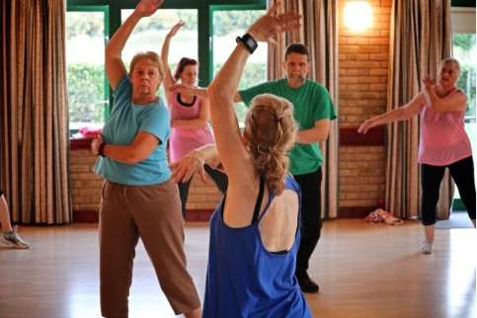
“I wouldn’t normally go to an exercise class because I would not feel comfortable. But I feel fine here. I think it’s because I know the people and it’s local” (Eye Bootcamp)
“I applaud Fit Villages for their promotion of Fitness across all age groups. The use of village halls rather than gyms removes the stigma of “body beautiful” to body fitness and body fitness promotes well-being and mental health. “ Freckenham FitSteps
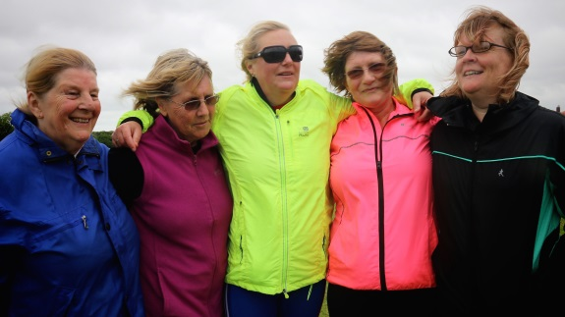
“It is good for the community and it brings people together. Everybody enjoys it regardless of how fit they are or what age they are. They can all come & enjoy it in some shape or form & it is doing them good.” (Pilates, Freckenham)
“I have awful sciatica in my back causing me serious pain every day. Since I started doing this class, the sciatica has gone. I can’t believe it. It’s amazing” (Shimpling, CB Pilates)
“I can’t really put into words what a great initiative it’s been & how it’s changed my life completely to be quite honest.” (Running, Kessingland)
Stakeholder Engagement and Leadership
Fit Villages is showcased by Sport England in its new strategy, for its contribution to wider social outcomes and best practice. The project is also recognised by stakeholders as a unique project that responds to Suffolk’s geography and demography and contributes to Suffolk’s collective Most Active County ambition. Key stakeholders include county, district and parish councils, public health, voluntary sector organisations and most importantly the local communities themselves.
Innovative Practice
Suffolk Sport’s wider active wellbeing programmes, including working with clients with long-term health conditions, has enabled significant learning around behaviour change models and approaches to engaging low participation communities into activity. Fit Villages applies these principles and translates them into the rural community settings targeted by the project.
Fit Villages has been working closely with Suffolk Sports Topcoach Academy programme to aid the development of our instructors. The instructors in the Academy have received mentoring, cross sport learning and CPD courses such as Behaviour Change and Social Media. This in turn has developed Fit Villages to reach more inactive participants.
Sustainability and Development
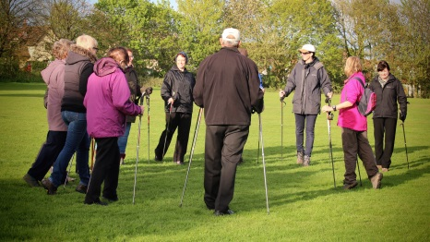
Projects are tracked and 85% of activities continue to run on a self-sustaining basis long after the initial 6-8 week funded intervention, demonstrating a very high level of sustainability. The programme already links with other organisations to deliver and signpost services to rural communities e.g. Rural Coffee Caravan, Suffolk Infolink, OneLife Healthy Lifestyle Service. Future development of the programme will expand the range of partners and services e.g. Suffolk Fire Service, Suffolk Mind and Age UK. In addition, future developments will see a more focused approach to targeting men within the older age group, which is a recognised challenge.

