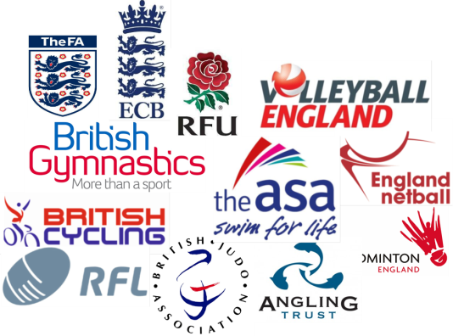

Project Title – TWS Coaching Bursary Scheme

Partnership – Tyne & Wear Sport, Newcastle College, NGB’s

Funding – Tyne & Wear Sport & European Social Funding

Project Aims: To support workforce development in the volunteer sport sector. Adding to the already successful TWS coaching bursary scheme, the project provides volunteer coaches with the opportunity to access heavily subsidised or free governing body Level 1 and Level 2 coaching awards in a range of sports.

Delivery Method: TWS worked in partnership with Newcastle College to access European Social Funding and enabled a co-ordinated delivery of 20 NGB coaching courses for volunteer coaches across the region. A TNA was undertaken in December 2014 with clubs and NGB’s to determine the workforce needs of local clubs. The results of the TNA survey were used by the Coaching Development Manager to create a workforce plan detailing a number of level 1 and level 2 coaching courses within Tyne & Wear between January 2015 – July 2015.

TWS worked closely with the NGBs to ensure the right people were given the opportunities to access these courses, which in most cases, were 100% funded through the European Social Funding as part of the Newcastle College Innovation project. The courses were open to all clubs although the NGBs were responsible for nominating and endorsing the most appropriate individuals to access this support. All individuals were aged 19 and over, were actively volunteering within a club environment and committed to completing the required paperwork and all required course files by the end of July 2015.

Evaluation: 10 Level 1 and 10 Level 2 coaching courses were delivered and completed during the seven month period, enabling 218 individuals to gain nationally recognised coaching awards. Individuals were representative of over 100 local community clubs and collectively gave back over 2500 hours of voluntary coaching. All are now actively assisting and leading coaching sessions in new and existing groups of participants ranging from 4 to 50+ age groups. This is without doubt the largest number of newly and further qualified coaches provided with additional training at any one time in Tyne & Wear. As a direct result community clubs have much needed sustainability, increased capacity to deliver and to also grow as a club. Examples of which are coaches delivering disability sessions, setting up women and girls teams and also delivering on Sport England funded projects, such as Satellite Clubs, Sportivate and School Games. In addition to the European Social Fundind, a further 90 coaches were supported through Level 1, 2 and 3 coaching and officiating qualifications funded through the Tyne & Wear Coaching Bursary Scheme.

Delivery Schedule:

Course | Partner | Cost per head | Delivery Date | Funded places | % Funding Awarded
Gymnastics Level 1 | British Gymnastics | £140.00 | January 17th 2015 | 3 | 100%
Cricket Level 2 | Durham Cricket Board | £275.00 | January 25th 2015 | 16 | 100%
Rugby Union Level 2 | Rugby Football Union | £83.00 | February 1st 2015 | 26 | 100%
FA Football Level 1 | Northumberland FA | £140.00 | February 2nd 2015 | 11 | 100%
FA Football Level 1 | Northumberland FA | £140.00 | February 16th 2015 | 3 | 100%
Judo Level 1 | British Judo Association | £100.00 | February 26th 2015 | 9 | 100%
FA Football Level 1 | Northumberland FA | £140.00 | March 2nd 2015 | 10 | 100%
Cycling Level 2 | British Cycling | £380.00 | March 7th 2015 | 15 | 100%
Judo Level 2 | British Judo Association | £380.00 | March 21st 2015 | 7 | 100%
Badminton Level 2 | Badminton England | £380.00 | March 28th 2015 | 7 | 100%
Rugby League Level 2 | The RFL | £200.00 | April 18th 2015 | 15 | 100%
FA Football Level 1 | Durham FA | £120.00 | April 21st 2015 | 21 | 100%
FA Football Level 1 | Northumberland FA | £140.00 | April 22nd 2015 | 6 | 100%
Netball Level 2 | England Netball | £360.00 | April 25th 2015 | 10 | 100%
FA Football Level 1 | Durham FA | £120.00 | May 9th 2015 | 17 | 100%
Angling Level 2 | Angling Trust | £440.00 | May 9th 2015 | 8 | 86%
FA Football Level 1 | Northumberland FA | £140.00 | June 1st 2015 | 6 | 100%
Volleyball Level 2 | Volleyball England | £450.00 | June 20th 2015 | 10 | 84%
Swimming Level 2 | ASA | £680.00 | June 22nd 2015 | 7 | 55%
FA Football Level 1 | Northumberland FA | £140.00 | June 22nd 2015 | 11 | 100%
 |  |  | Total | 218

