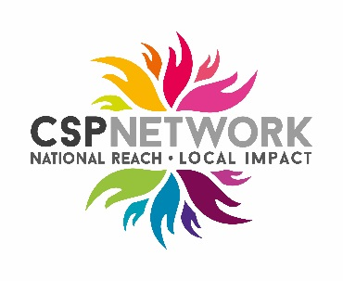
Redcar Boxing Club
and Development Trust
Punching Above Their Weight
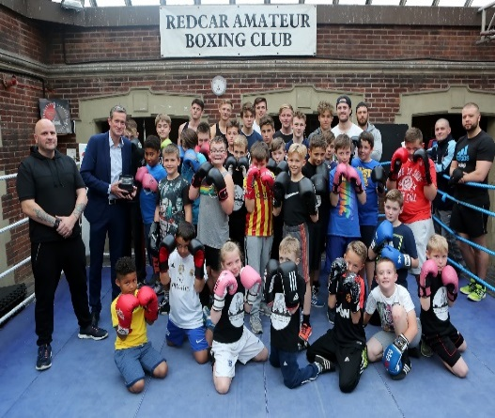  Click on image to view film  Impact  - Secured £90,000 of funding to support community outreach work from the club  - Created a new full-time Outreach Coach post  - Delivering 500hrs of coaching support working in partnership with Cleveland Police and Redcar & Cleveland Council Public Health Team  - Delivering mobile ring sessions in socially disadvantaged communities working with Cleveland Fire Service  - Targeted 500 young people over a 6 month period  - 50 subsidised 3 month membership passes to the boxing club for young people to continue their engagement with the club  - 35 people signposted to volunteering and skills development opportunities  - 10 people gaining coaching qualifications  - Produced a detailed evaluation of the project to support similar sport based interventions  Tanya Gray, Tees Valley Community Foundation  ‘Helping community organisations to build capacity, generate new funding and become economically sustainable are our strengths and we have been delighted at the impact already made with the club’  Matthew Williams, England Boxing  ‘The partners on the Steering Group bring so much knowledge, experience and insight. The club has always been very well respected, but this new partnership has added another dimension to their work’  Stephen Mussett, Redcar & Cleveland Public Health  ‘The Council has limited resources and we want to work with sports clubs to help support a number of public health initiatives. This project is a great example of what can be achieved by getting the right partners working together and we would be keen to replicate with other clubs’  Frankie Wales, Redcar Development Trust & Boxing Club  ‘We were really pleased to initially win the Sportivate project award and this has given the club the encouragement to expand our work further as we feel that we have a great resource that should be accessible to everyone in the Redcar & Cleveland area’  Nicki Wiley- Former Steel Worker  ‘The funding has provided me with a great opportunity to develop a new career and I am gaining valuable experience working in schools and encouraging people of all ages to be more active’ | We began working with Redcar Development Trust & Boxing club in 2012. Boxing is a key strand of activity for the Development Trust offering opportunities for local people to improve boxing skills. There is a strong focus on reaching out to disengaged young people in some of the most disadvantaged communities in England.  The club developed a pilot project in partnership with Tees Valley Sport to improve their social & community work and specifically deal with public nuisance issues identified by local police and using insight gained from local council services. Using Sportivate funding, they set up mobile boxing rings in 4 priority estates in Redcar on Friday evenings. Over a 4 week period, 40 young people took part in activity with almost 60% subsequently attending Sportivate ASBOx training sessions at the club. This initial pilot was a great success and was recognised through the club winning the 2015 North East regional Sportivate project of the year award.  The club were determined to build on the success of the Sportivate project and help address high levels of inactivity & obesity and very high levels of unemployment which are prevalent locally. They are fully committed to delivering local projects for the community which are located in areas of significant disadvantage  Social & Community Development  Sportivate has been the catalyst for the development of a much wider and innovative programme of outreach work involving a variety of partners targeting all sections of the community to engage in sport and physical activity. We have played a key role brokering new partnerships, generating resources and evaluating programme delivery. The project has achieved a lot in a relatively short period, and clearly illustrates the impact that sport can make in supporting physical & mental wellbeing, individual development and social & community development.  We have worked with Tees Valley Community Foundation, England Boxing and Redcar & Cleveland Council to develop targeted interventions. A Steering Group was established sharing insight & knowledge and initially supported an application to the local Police Crime Commissioner. A grant of £10,000 was the starting point for other funding applications and has enabled the club to build on Sportivate, working with new partners to deliver projects at a local level tackling inactivity, targeting children & young people, promoting volunteering and helping to support and sustain the existing membership base at the club.  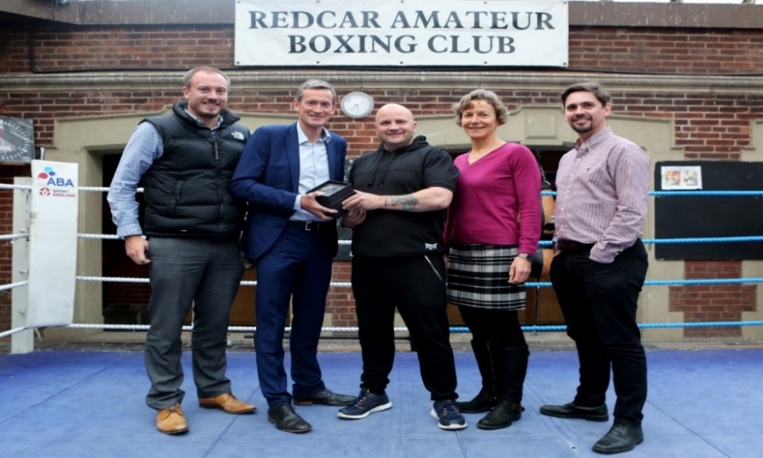  The club have been particularly keen to target local schools to engage more young people earlier and we have brokered new links with Primary Schools through Primary School Sport Premium work, working closely with Redcar & Cleveland Council Public Health Team. The Tees Valley Active Schools project has been a key area of work, encouraging teachers, pupils and the wider school community to be more physically active. Redcar & Cleveland has some of the highest childhood obesity levels in the country and the club are now working closely with the Steering Group using insight and local knowledge to target their resources to make the biggest impact.  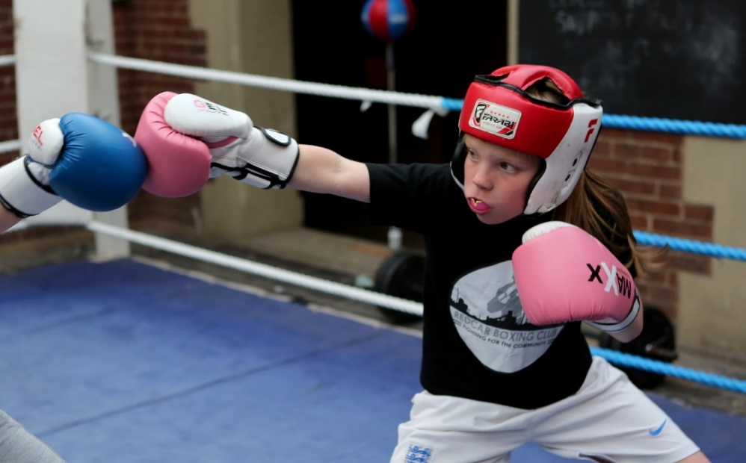  Individual Development and Mental Wellbeing  The club have successfully matched the Police Crime Commissioners funding with resources from the SSI Jobs Fund, set up following the closure of Redcar Steel works in 2015. The club is at the heart of the local community that has been severely affected by the Steel Plant closure and they are working with former steel workers to identify new business start-up schemes in sport and identify suitable volunteering and training opportunities to increase employability.  The SSI Jobs Fund has provided resources to employ a former steel worker as an Outreach Coach at the club. The new coach has joined the Tees Valley Sport Coach Mentoring scheme where he receives support from an experienced local coach. Work includes partnering with MIND to support women who have mental health & substance abuse problems and service veterans with specific physical and mental health rehabilitation needs which have been identified as priority areas by the local Public Health team. The club are working with both groups signposting clients to physical activity and volunteering programmes. This is another great example of their commitment to help improve the quality of life for residents in Redcar & Cleveland.  Sustainability and next steps  We have built up a strong working partnership with Tees Valley Community Foundation. The Foundation are now providing direct support to the club with a focus around sustainability, business development and building a robust evidence base through the evaluation of project work.  The business support work is specifically looking to further develop links with Cleveland Police & Fire Service and expand work with the youth justice system & probation services with a view to collaborative interventions in the future. Working with local housing associations and providing evidence of the value of sport in addressing issues such as estate based vandalism, hate crime and drug & alcohol misuse is another key area of work. Based on the success of the partnership work to date, we are confident that we can identify a delivery model capable of creating a step change in engagement in sport and physical activity that we can use to promote locally & nationally.

